MORE DATA PRACTICE

- [3 marks]
Classify each numerical variable as a DISCRETE variable or a CONTINUOUS variable.

- The numbers of brothers and sisters a person has. _______________________

- The time it takes to travel from A to B in minutes. _______________________

- A person’s weight in kilograms. _______________________

- [4 marks]
Sketch what you consider to be a reasonable HISTOGRAM for the following:

The number of children in approximately 50 families, each of which have at least one child.

Your HISTOGRAM does need a scale on the Horizontal axis.

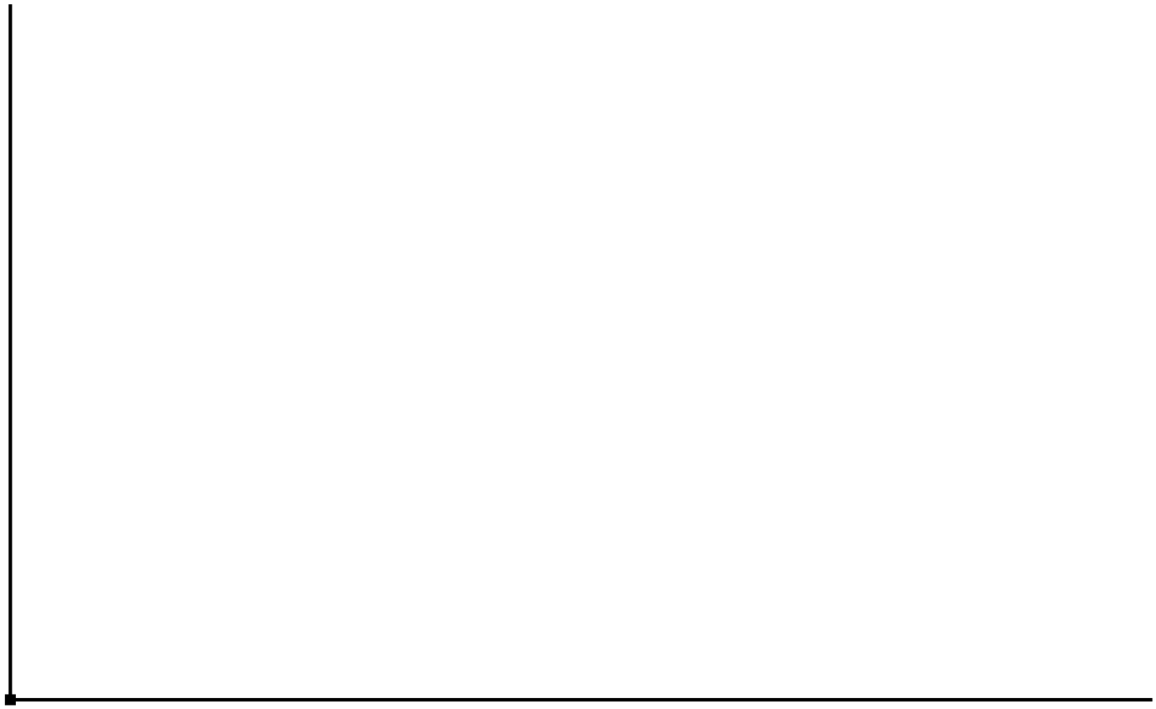

- [4 , 6 marks]
Thirteen students completed a “Standing Jump Test” and the distances (in cm) they jumped are recorded in the Stem and Leaf plot below.
Calculate the Mean, Mode, Median and Range for the data.

23 | 1 3
24 | 4 4 4
25 | 2
26 | 5
27 | 7 7 8
28 | 6 9
29 | 0

- b) Construct a MEDIAN BOX and WHISKER plot for the same data,

- [4 marks]
These results are for Duncraig SHS for the Semester One Year 9 Examination in 2015.

Class | Mean | Number of students
Class A | 62.45 | 25
Class B | 47.17 | 28
Class C | 58.73 | 30

Use the above results to calculate the overall examination average for these three classes.
You must show your working to get full marks. Give your answer accurate to 1 decimal place.

- [2, 1, 1, 3 marks]
The following are 8 prices (to the nearest $1 000) for homes sold in Duncraig over the last year.

$567 000 $523 000 $534 000 $712 000
$576 000 $599 000 $723 000 $596 000

- Find i) the Mean Price (to the nearest $100).

- the Median Price.

- How many house prices are below the Mean Price?

- How many house prices are below the Median Price?

- A ninth house is sold for $650 000. Which measurement, Mean or Median, changes the most?
You must have suitable reasoning or results to support your statement.

- [3 marks]
Using the given data for the two distributions (which use Raw Scores not percentages),
decide which Student Score is the better score and explain why?

Distribution A Raw Mean = 40 Standard Deviation = 6 Student score = 46

Distribution B Raw Mean = 64 Standard Deviation = 8 Student score = 70

- [6 marks]
Compare the two MEDIAN BOX PLOTS shown below.

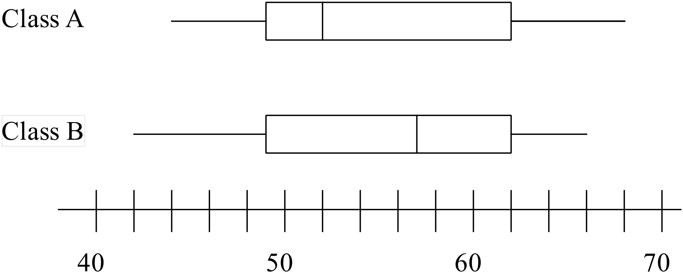

- [4 marks]
Describe the distribution shown in the Histogram.

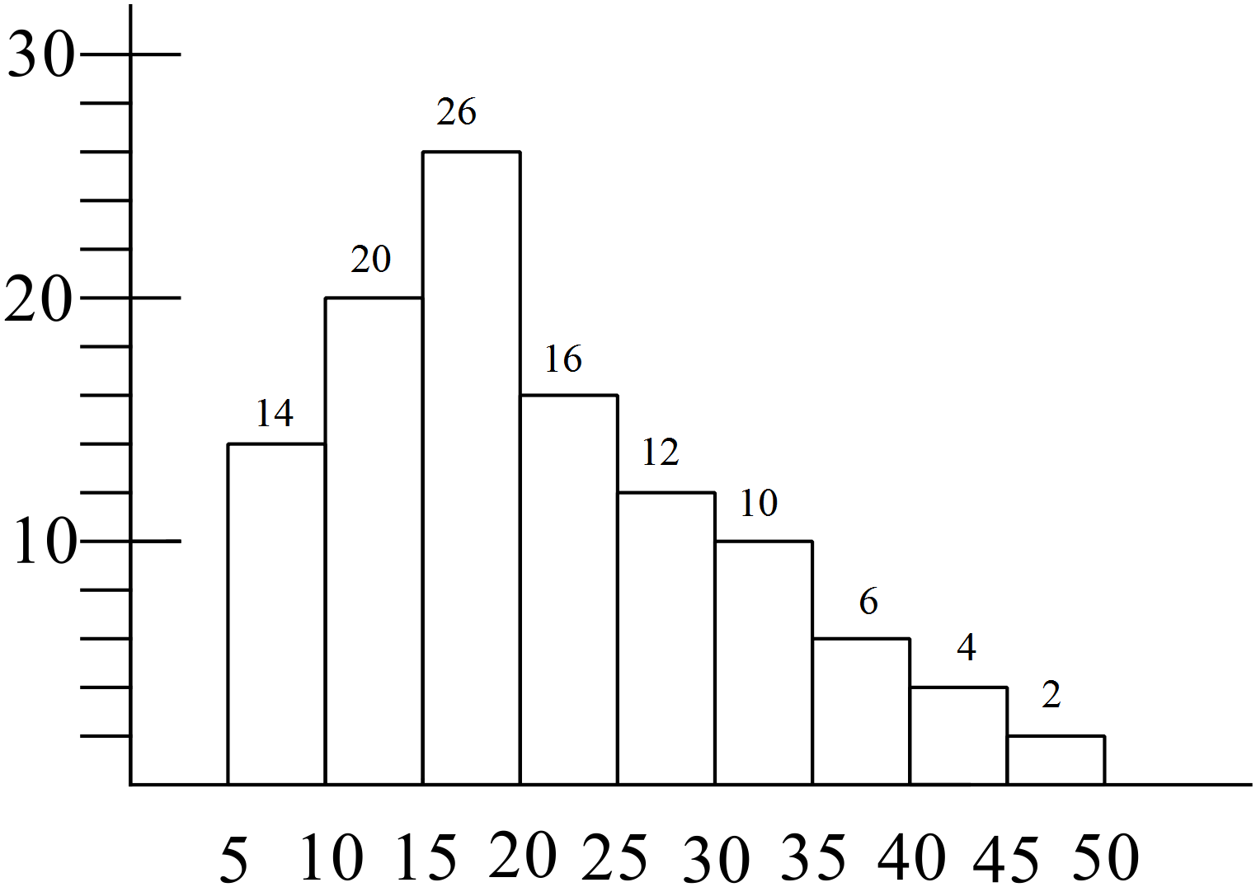

- [3 marks]
For the data set below calculate the Mean and Standard Deviation, accurate to 1 decimal place.
(These are only estimates of the actual values).

Interval | Number of students
20 ≤ x < 30 | 3
30 ≤ x < 40 | 7
40 ≤ x < 50 | 12
50 ≤ x < 60 | 10
60 ≤ x < 70 | 5

